Functional User Story Template

User Story Template will guide us during the writing of user requirements, this will give you the tools to make the start of a project easier and to be able to switch between projects no matter technology or requirements differences.
At the beginning of a project we start with high level functionality and it’s difficult to go deeper on describing a user story.
So before starting to write stories you have to be sure you are done with splitting general functionality into several parts to create your product backlog. You can start by naming each story, don’t worry about detail.
It is valid to have broad user stories, we will call it Epics, and those are going to be split and detailed in future sprints.
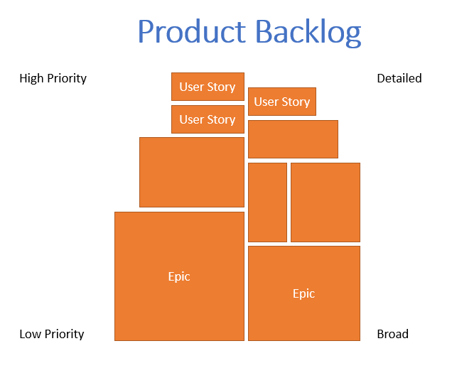
Then select High Priority stories and apply the Scio’s User Story Template to each of them, which consist of:
- Title
- Description
- Satisfaction Criteria
Let’s take a tour into each of the parts of the template.

Title
A brief description of the story, should be easy to recall and meaningful.
Be sure you accomplish next checklist:
- If users or customers read it, it will make sense to them?
- Does make sense for the programmer?
- It is short enough to read it out loud in less than 5 seconds?
All answers should be yes.

Avoid
- Writing unnecessary words
- Going too technical
- Repeating names

Good Practice
- Putting the name at last, so after you wrote the whole description you can have a better idea of how to resume it
- Write it as if you were the user
- Keep it short and remarkable, like a song’s name

Description
It’s a structured narrative of the story, for instance:
As a UserRole I can functionalityDescription to valueDescription
As a Manager I can create new locations to provide customers another alternative to order their food online
Make sure you are responding in a couple of words and being specific to each of the questions below after writing the story description
- Which role(s) is receiving value by doing this story? (need to be specific)
- What function is going to do the user with it?
- Which value is receiving the user by doing it?

Avoid
- Writing the word “User” as the user, remember you have to be specific
- Putting in value something that does not represent a real value to the user

Good Practice
- Write it as if the user was telling it “I can do this because it helps me to that” (first person perspective)
- Making sure what you wrote as a value truly represents value to the user
- Having a role-functionality matrix, so everyone can check what a user can or can’t do in the application

Satisfaction criteria
A list of business and usability rules working as a checklist that the developed functionality has to accomplish in order to consider it done.
The content of the list would be different between user stories and projects, but it has to be available and updated while the story is in progress.

Avoid
- Going too specific on validation of fields
- Writing when you can explain it better using an image
- Writing when it’s better to make a quick excel functionality or table to show the behavior

Good Practice
- Making a file for or mock up to describe data or field validation
- Having a list of project inherited behavior or general satisfaction criteria that would apply to all features in the application (UX, grammar, storytelling, validations, etc.)
- Write them as if the user is speaking about it, like “I can I see a confirmation message before deleting a record (Are you sure to delete this record? Yes / No options”). It is always good to define the explicit message so grammar and spelling errors are avoided
- Consider as satisfaction criteria the integration with other functionalities, for instance if you are deleting a record you have to consider to not showing that information in some other parts of the system and to refresh grids. QAAs have identified that this is the main reason changes are rejected on the first round of QA

Sprint values

Assigned to
If you are creating the user stories, remember to always assign them to you while these stories are in a New state. No user stories should be without a person assigned, remember that what is everyone responsibility is no one responsibility, so make sure you are assigning stories to you or any other person in charge from taking a New story to Approved.

State
Stories have several paths to achieve their final Done state, but all of the stories start on a New state. 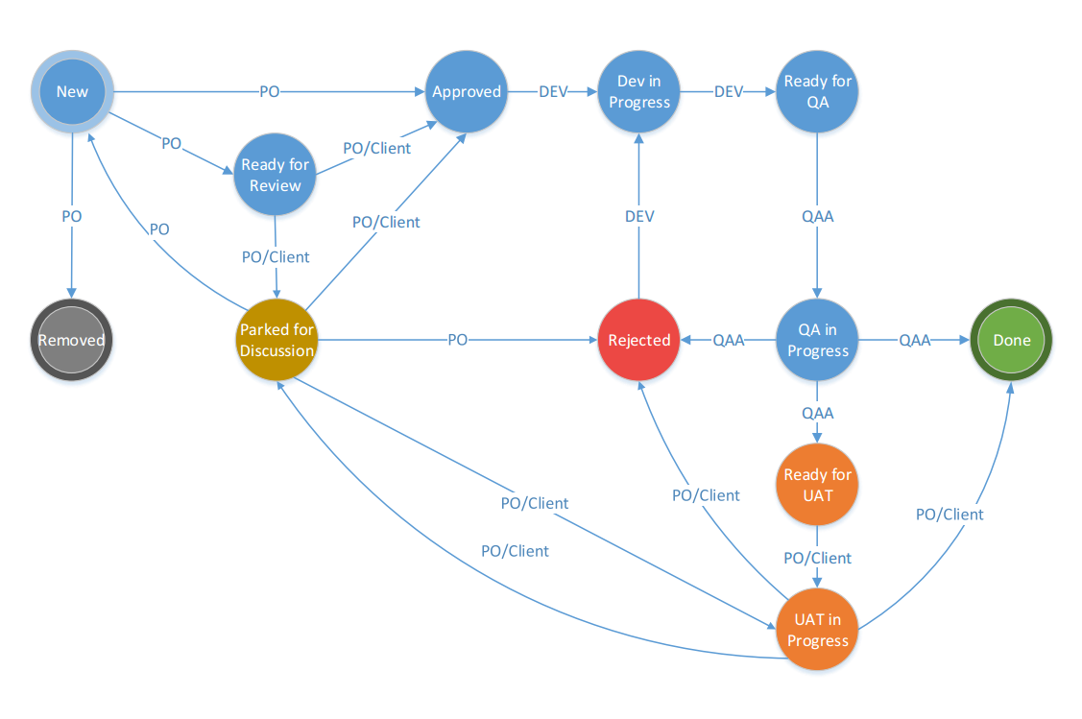
Every time you create a story assign the New state, so you fill all the structured description and satisfaction criteria. Once it’s ready you can pass it straight to approved state in case you already have enough information from your client, otherwise place it in Ready for review state.

Backlog priority
You will decide according to your client needs the priority of your backlog items. The convention in Scio is to express it in a 5 digit number that contains the Phase, Sprint and Priority. Let’s take a look.
30220
Phase: 3
Sprint: 2
Priority: 20
A good practice is to use the whole priority range from 1 to 99 in each sprint, this way you can fit new backlog items in between, for instance, “Create Users” can have 20 as priority, and “Delete Users” can have 30 as priority, so if you add “Create Roles” as new story you can put it in 25 priority

Business Value
Business value is the story points that the team assign on an estimation session. But you can not to leave business value with no value, so place 1 as value until the team estimates.

Technical Story Template
There are some activities that are not user requested by the user, but during the project the team foresees that have to be done to accelerate the rhythm of the development or to ensure that Scio’s core value is going to be delivered (like quality, good performance, usability, scalability, among others).

How to identify a technical story?
Not every activity can be defined as Technical Story, look that we don’t use the term user story because is not user related. In case is user related we can have that activity as a task on a user story or as a satisfaction criteria. Let’s make it easier to remember.
- Does the activity was requested by the user?
Then create a user story with the traditional format, make sure you are writing the value the user will get. E.g. “As a Cashier I need daily reports to be uploaded automatically to central servers so that would reflect my daily performance and transactions in the company”
- Does brings value to the user?
If the user did not asked for it but for some reason it will bring added value to him let’s look for an existing user story where we can express the activity as an acceptance criteria. If that is not possible we can write a new story where the main purpose of it is to implement that value. Be careful on not to add user stories all the time, you can be trapped into generating project working hours when it is really debt of thing that were not taken into consideration in early stages of the project
- Does brings value to the team and the team only? (Devs, POs, QAAs, PM)
If there is a part of the code, class or organizing project managing activity that will only benefit the way the team is working it is better to not create a user story in a typical way. We need to create an Item, a technical story that will be written by technical member of the team so everybody else can truly understand it.
Technical leader should decide when it is time to develop a technical story and should write it. Product Owner must be aware of the impact and checking if the story has full description and acceptance criteria. Once you have determined which of your stories are technical apply the structure below.

Title
Name of the story, can be technical, should be easy to remember and be meaningful for the developer

Description
Not structured, technically fluent and provides the benefit (value) for the team or development process by implementing this item

Satisfaction Criteria
It should provide specific metrics to approve the story, written in a technical point of view. For instance if it’s performance should stablish range of acceptable response time, if it’s scalability of more modules then the satisfaction criteria should specify how and how much it is going to be scalable, so this will allow QAAs to perform precise

Cross-features requirements
Some requirements are general and need to be validated in every single feature, but sometimes we forget to check them, or developers focus on the main value of the story because most of the time because we did not explicitly wrote the general requirements.
Write down a file with a list of specific criteria that must be achieved in each user story, it could be performance, usability, length validation, grammar and spelling, look and feel stuff, use of punctuation, alignment, performance, technical restrictions, among others.
To consider a requirement as a Cross-feature look for

Generality
If you notice some acceptance criteria that repeats in every feature you can consider it a generality. Like “It should be free of grammar and spelling errors”, to avoid typing the same rule over and over again you can refer to the Cross-Feature requirements list.

Common Sense
If you think the whole system should behave or present features in a way do you think is common sense, do not expect everybody in the team will guess it. Be explicit and create a general rule, it does not matter if it sound obvious, like “After running a report if it does not return data it should display the message No records found” or “All controls should be finger size because it’s a mobile app”. You may think this is obvious but remember to make it explicit

Customer restrictions or request
Most of the customer have restriction on technology they are able to use, like minimum requirements on browser versions, minimum screen resolution, and device type. Also customers have some specific requests to all the features of the system like using certain colors, mailing and notifications methods, multi-device or multi-browser or even words.

User experience
Always remember where the user is going to use the application, how and in which devices. It is not the same to use web application on a tablet on the go than in a large screen on a desktop computer, or trying to use an application at the office rather than a kitchen. Be truly emphatic, imagine where is going to use it and the conditions of if, gender, age and abilities.
Make sure to estimate stories having the Cross-Features requirements list, remind that those requirements should be addressed too at the estimation session. You can create a list or a Checklist that can be easily attached to the story or copy pasted into the description.
Go to hands on section for example.

Attachment support

Mockup
An image says more than a thousand words, this is the advantage of a mockup where you can draw and show exactly how the user is expecting a screen and user controls. It is very important that you can validate mockups with the customer, to ensure that the team and the customer share the same idea, also it is good to talk to technical leader each time you need a new control tools (lists, trees, reporting tools, menu types, collapsible areas, etc.) to foresee any technological restriction or another solution.
Something you have to avoid is spending too much time on drawing, keep it simple but substantial. It is important to add notes to the drawing so you can express business rules and some expected behavior, do no overuse it, another key to a good mock is to make sure you are presenting prompts or modals so you can be explicit on the behavior of a button and to look of the additional windows .
A mockup would never replace a list of business rules and acceptance criteria, remember it is support to the user story.

Better use them when
- It´s a new project where you don’t have previous screen base models
- You have to describe visual sections and common control behavior
- You have a team that it is visual oriented understanding
- If you are sketching a mobile app, it will give a better sense of space in the screen

Do not use it if
- You are trying to show calculations
- The satisfaction criteria of your story is more business-rule based
In Scio we have Balsamiq tool to draw, modify and export mockups, has tons of predefined controls and icons to make the sketching easier. It is always valid to draw mockups by hand and attach them to the user story, the downside is that is more difficult to keep them updated and available for the whole team.

Functional spreadsheets
Sometimes it is better to show how to do something instead of telling someone how to do it, take for instance when you are learning to swim, It would be way better to show and practice 1 time on the pool than having a year of theory and explanations at a classroom.
Spreadsheets allow us to:
- Show how to calculate according to the business rules of our project
- Present tables as it should be in the application grids
- Display mock data with interactions or formulas on it
It does not necessarily need to be fully implemented but it is a good way to confirm an expected functionality with the customer.

Role Matrix
QAAs reported me is that they usually do not recall which users have access to a feature described in a user story. Sometimes is because the User Story says “As a User” literally, so no one knows which of all the users of the systems is referring to, or it’s because many users have access to that feature and are not listed in the Description nor the Satisfaction Criteria.
A way to remember which user have access to some features and keep validation under control is to generate the Role Matrix, which basically is a matrix with Roles as column names and rows as Features of the application.
Take a look on the following example
 | Admin | Manager | Cashier | Customer | Marketing
Create Products | YES | YES | NO | NO | NO
See Catalog | YES | YES | YES | YES | YES
Place a complaint or suggestion | NO | NO | NO | YES | NO
Place an Order | YES | YES | YES | NO | NO
Sales Report | YES | YES | NO | NO | YES

All the features that a user can use are marked green and YES, this makes easier to identify what a user can or can’t do by filtering data. You can always add new users at the top right column, just make sure you are also adding what the user can do.
If you want awareness of what roles are able to perform a feature you can create your Role Matrix inverted, use Features as columns instead, downside is that your matrix will grow horizontally and it is more difficult to read.

Hands on
Let’s practice on a project so you can do it with yours.
- Please read the project description so you can be aware of the customer needs and create stories.
Project description

Kori and George run a famous bakery across the United States called “Kori-US-George Bakery”. They have stores at different locations, the business has been split in regions and each region has their own regional special cakes and bread with several other products that are all along the country.
They are requesting us a Web and Mobile Application so customers can see their products, navigate across them, customize certain things like decoration, colors, labeling, notes, packaging, more or less ingredients, sweetener type (every custom decision have an impact on the price), make and order and purchase using Credit Card, PayPal, Coupons and cash (on site) as payment methods.
The user has to be aware of the steps of the purchase all the way, to go back and forth, and to be sure if the purchase was properly done or if an error occur. Billing and order notifications/emailing should be sent every time the user makes a purchase. Mails and notification will contain links to details of the order or downloadable bills.
Registered users can share their purchases on Instagram, Facebook, SnapChat and WhatsApp, every share should have a mask or filter with colors of the company and logo. Every time the user shares will get random coupons. They will also be able to write down a complaint, a suggestion or to congratulate the company or a member of the company.
Cakes and products will be delivered only on zone-coverage of the existing locations, up to 20 miles. There will be a zone of tolerance beyond the limit but it will be an extra charge for that. The user can also pick up the product on site with no charge, with a time limit so the cake can still be fresh, limit time is setup by the regional managers.
Customer should be registered and logged-in to make an order, it is not necessary to be registered to explore and configure cakes.
Kori and George have to delegate actions to their location managers, so the managers will have to be pending of the customer orders, change status of them and being able to see tendencies of requested cakes and product. The managing application should be able to break down each of the ingredients usage so they can be aware of making an order to their suppliers. Managers can update the cost of some local ingredients, there should be a historic of pricing, others ingredients will be received directly from the providers that negotiate price on nationwide locations as a whole, so these ingredients should be the same across the country like eggs, flour, sugar, milk, butter. Also they can look for personal information of customers, what is what they order and why they are ordering (anniversary, birthday, whim, friend reunion, office event, etc.), this to identify customer tendencies and offer them better prices or special gifts on their orders like coupons or new products samples.
Owners and regional managers can create new recipes to upload them to the locations, not necessarily to all of them. Each recipe should be break down into ingredients, cost of ingredients, and cost of energy, price, profit and customizable stuff per recipe, price of each customizable stuff. They will be able to watch general, regional and specific reports of the orders, most requested products, and bottom requested products, more profitable products, earnings, costs and profit per product. Also they can watch and see personal information of customers, what is what they order and why they are ordering.
All managers and owners can keep track and respond to customer compliments, suggestions and complaints from the registered users. They can watch them in Facebook news feed style. All managers and owners can create the availability of the random coupons.
- Go to the KoriUSGeorge TFS Project, you should have access already
  - http://venom:8080/tfs/DefaultCollection/Scio-Kori-US-George-Bakery/_backlogs/Iteration/Release%201/Sprint%2001
- Select one of the stories, assign it to you if it is not already taken and assign a Tittle that fits the description you are about to write and that accomplishes the Titling rules
- Write down the structured description and make sure it does respond to each of the 3 questions stated above
- Create the list of acceptance criteria, make sure you are listing the rules and support the story with a mockup, excel file or another support you may need
- Once you are done pass the story to review
- You may receive comments to improve the content of your story, then you have to implement that so your story can pass to done
- Once your story is done you are ready to replicate the template on each your projects, congratulations.

“Thank you for reading and applying, have a great user storytelling”
--Jesús Magaña

